CHF BLACK AND GREEN MARCHING MACHINE:
EMERALD ELEGANCE MAJORETTE
TRY OUTS!
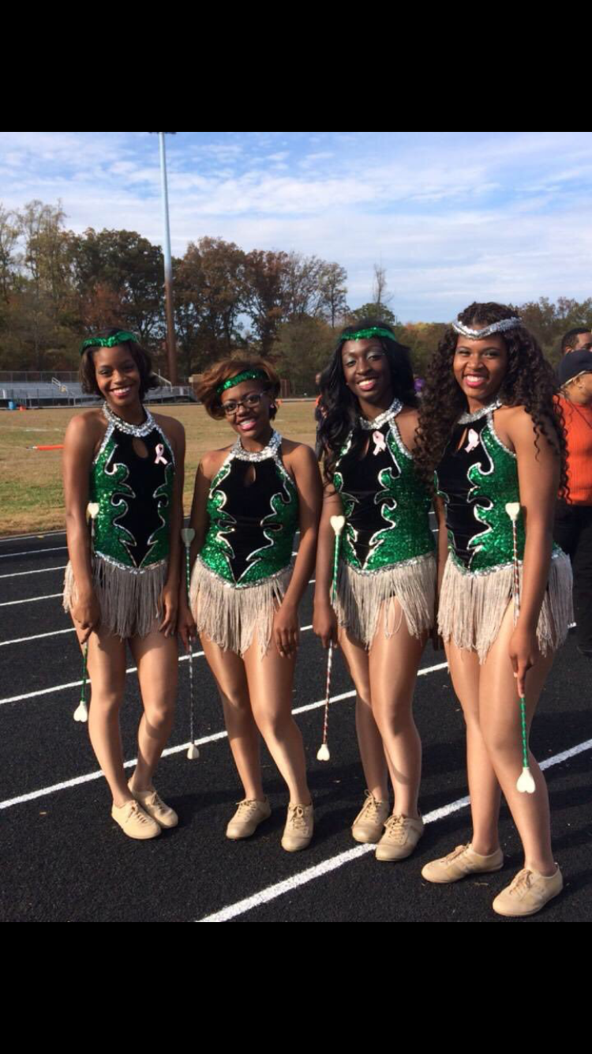
If you’re interested in dancing and would like to learn how to twirl a baton, come and tryout to be a Majorette!
Where: Band Room
Interest Meeting: May 15
Time: 2:50 until 4:00
Try Out Dates: May 16-18, and 22-25
